**EXPERIMENT-7: Title: DYNAMIC PROGRAMMING-II**

1. Given two sequences, find the length of longest subsequence present in both of them. A subsequence is a sequence that appears in the same relative order, but not necessarily contiguous. For example, “abc”, “abg”, “bdf”, “aeg”, ‘”acefg” etc are subsequences of “abcdefg”.

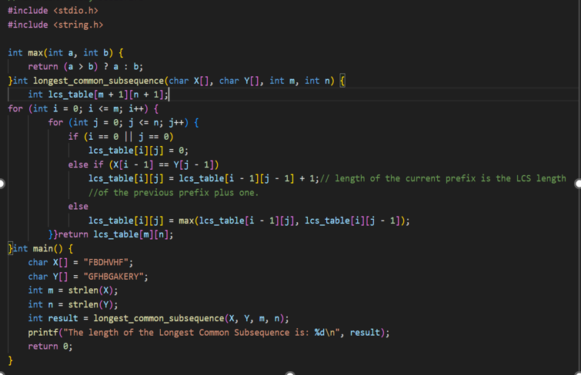

Output:

